

50

Target: ______/50 or ______ % 👍 👎

Year 9 HASS- Geography

***Task 2: In Class Content Assessment Biomes & Food Security (5.0% weighting)***

***MARKING KEY***

**SECTION ONE – MULTIPLE CHOICE**

Read each key term, or statement, and circle only one option from A-D with a pencil as your response.

1. A Biome is best defined as: **(1 mark)**
2. A biome is a specific environment that is home to all living things suited for that place and climate.
3. A biome is a very large ecosystem.
4. A biome is a very large ecological area on the earth's surface containing fauna.
5. A biome is only found in oceans, river estuaries and coastal wetlands.
6. Which of the following is NOT a biome? **(1 mark)**
   1. Mangroves
   2. Tundra
   3. Tropical Rainforest
   4. Plantation
7. What characteristic are biomes named after? **(1 mark)**
8. Most common animal
9. Most common vegetation
10. Average climate
11. None of the above
12. Which of the following is NOT a cause of food shortages? **(1 mark)**
13. Rises in prices of staple foods
14. Pesticides
15. Population growth
16. Climate change
17. What is the cause of the most widespread damage to biomes? **(1 mark)**
18. Erosion
19. Cattle grazing
20. Land clearing
21. Tourism
22. If a population has safe access to nutritious food, it is said to be; **(1 mark)**
23. Food insecure
24. Food secure
25. Developed
26. Undeveloped
27. Which of the following is a characteristic that determines the biodiversity of a biome:

**(1 mark)**

Latitude

Precipitation

Height above Sea Level

All of the above.

1. Which of the following is a biome not found on the Australian Continent? **(1 mark)**

Desert

Mediterranean Savannah

Tundra

Tropical Rainforest

1. What is the name of the line of Latitude where most of the world’s tropical rainforest biomes are located near? **(1 mark)**

Prime Meridian

Tropic of Cancer

Tropic of Capricorn

Equator

1. Land based biomes are called; **(1 mark)**

Land based biomes

Terrestrial biomes

Aquatic biomes

Lithosphere biomes

**SECTION TWO – SOURCE ANALYSIS AND SHORT ANSWER**

Refer to **SOURCE 1** to answer the following questions;

1. What does the dark green colour represent on this thematic map? **(1 mark)**

Under 5% of the world population is undernourished

Under 5% of the population of that nation is undernourished

Under 5% of the population of that nation is nourished

Under 5% of the population of the world is nourished

1. Which of the following continents is experiencing the most food insecurity? **(1 mark)**

Asia

Australia

South America

Africa

1. Which three continents are not experiencing undernourishment and food security problems? **(1 mark)**

North America, Europe, Asia

North America, Europe, Australia

North America, South America, Europe

North America, Australia, Asia

Refer to **SOURCE 2** to answer the following questions;

1. Which statement below, best explains what Mean Annual Temperature is? **(1 mark)**

The average temperature over a week

The normal temperature over a year

The average temperature over a year

None of the above.

1. What information is found on the y-axis of the graph? **(1 mark)**

Mean Annual Temperature (°F)

Mean Annual Precipitation (mm)

Mean Annual Temperature (°C)

Mean Annual Precipitation (cm)

1. What is the name of the biome that receives the highest Mean Annual Precipitation and the Highest Mean Annual Temperature? **(1 mark)**

Tundra

Desert

Temperate Rainforest

Tropical Rainforest

1. Which of the following characteristics is affected by the amount of precipitation and range of temperatures found in the biomes? **(1 mark)**

Elevation

Vegetation

Latitude

Longitude

Refer to **SOURCES 3 AND 4** to answer the following questions;

1. State which biomes are mostly used for cropland? **(2 marks)**

GRASSLAND, SAVANNAH AND TEMPERATE FOREST (ANY COMBINATION OF THESE)

1. State which biomes are mostly used for pasture, i.e. animal grazing? **(2 marks)**

GRASSLAND, SAVANNAH

1. State which biomes produce the least food? **(3 marks)**

TUNDRA, DESERT, ICE, TAIGA

1. State what SPICESS stands for: **(7 marks)**

S - SPACE

P - PLACE

I - INTERCONNECTION

C - CHANGE

E - ENVIRONMENT

S - SUSTAINABILITY

S - SCALE

1. Choose two of the 7 key concepts of geography and **define** these concepts using an example of biomes or food security. **(4 marks)**

MAY CHOOSE ANY OF THE 7 KEY CONCEPTS

* + - * + 1 MARK FOR CORRECT DEFINITON FOR EACH OF THE CONCEPTS CHOSEN (2 MARKS IN TOTAL)
        + 1 MARK FOR APPROPRIATE EXAMPLE FOR EACH OF THE CHOSEN CONCEPTS (2 AMRKS IN TOTAL)

1. List the four spheres for the acronym BLAH. One has been done for you. **(3 marks)**

B -*Biosphere*

L - LITHOSPHERE

A - ATMOSPHERE

H - HYDROSPHERE

1. Annotate each of the four spheres of the picture below. **(4 marks)**

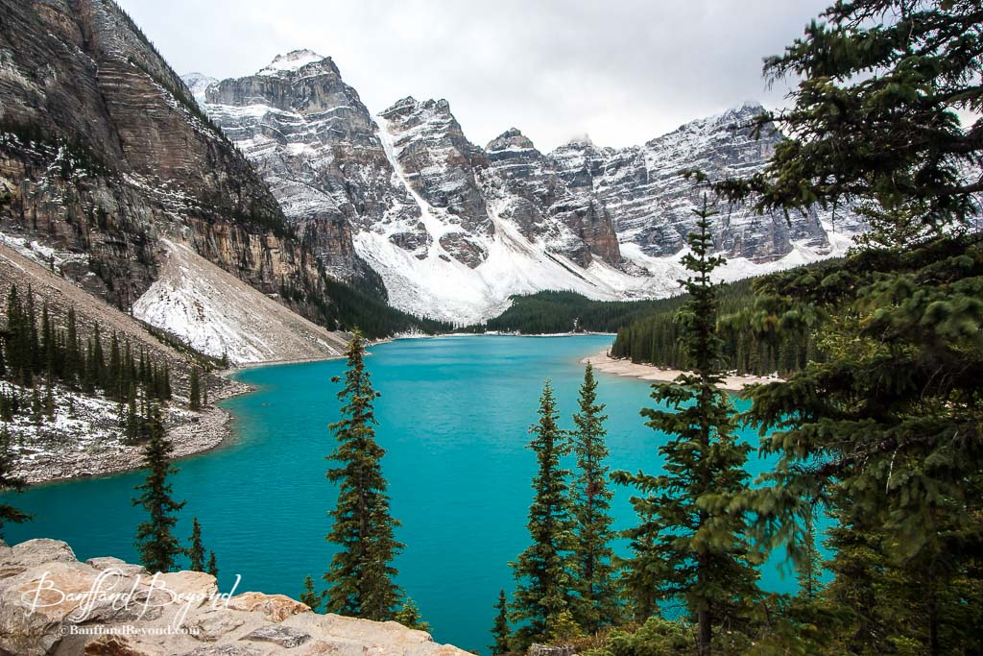

ATMOSPHERE

LITHOSPHERE

BIOSPHERE

HYDROSPHERE

1. Define food security and provide an example. **(3 marks)**

MARKS ALLOCATION:

* + - * + 2 MARK FOR A CORRECT DEFINTION OF FOOD SECURITY,
        + 1 MARK FOR AN APPROPRIATE EXAMPLE
        + MUST BE FULL SENTENCES AND WELL STRUCTURED FOR FULL MARKS ALLOCATION

1. With reference to a biome, specifically climate factors (precipitation, temperature) describe the relationship between climate and food security. A good answer will make reference and give specific examples of climate factors. **(5 marks)**

MARKS ALLOCATION:

* + - * + 1 MARK FOR A BIOME SELECTED AND MADE REFERENCE TO
        + 1 MARK FOR SPECIFIC EXAMPLES OF THE CHOSEN’S BIOMES CLIMATE CHARACTERISTICS
        + 1 MARK FOR A CLEAR LINK AND DESCRIPTION OF HOW THESE CHARACTERISTICS EFFECT THE FOOD THAT CAN BE PRODUCED IN THE CHOSEN BIOME.
        + 1 MARK FOR SPECIFIC EXAMPLES OF FOOD SECURITY/INSECURITY AND THE BIOME SELECTED
        + 1 MARK FOR A WELL STRUCTURED ANSWER THAT FOLLOWS THE KEY DIRECTIONAL WORD “DESCRIBE”

GIVE A THOROUGH ACCOUNT OF SOMETHING, PROVIDING CHARACTERISTICS AND FEATURES.

ANY ANSWERS AWARDED FULL AMRKS MUST BE MODERATED.

**End of Assessment**